Entering Athletes on OpenTrack

Guidance

# Step 1

Click on the green ‘Enter Here’ button, as shown below:

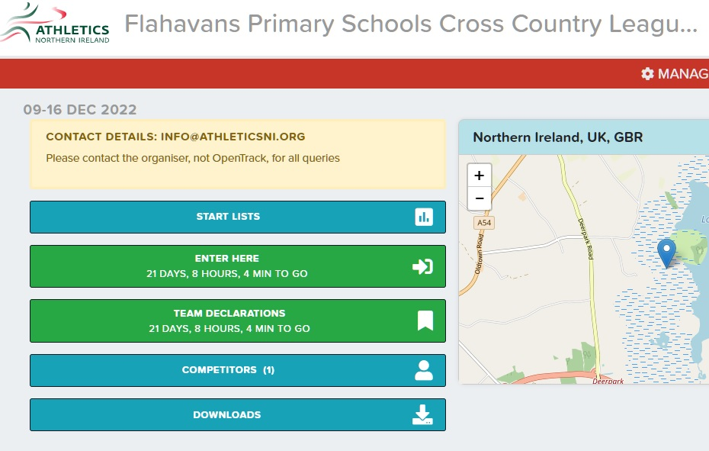

# Step 2

For a new athlete click ‘Enter nationality and name, to see if you are on the database…’ and type ‘New Athlete’ into the box- this will give you a drop down menu which shows the following:

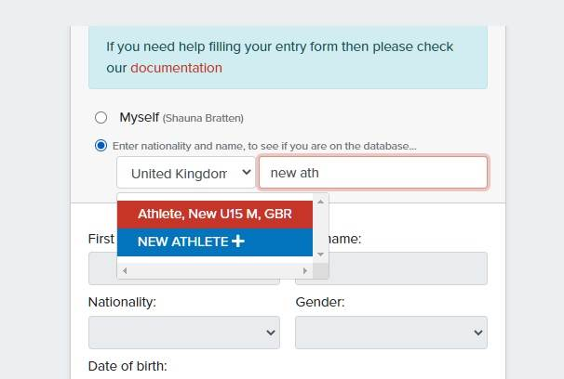

Select the blue ‘New Athlete +’ button and this will allow you to enter the details of your pupils in the boxes below. Once you have entered your pupils’ detail press ‘Ok’.

# Step 3

If the correct pupil has came up press ‘CONFIRM’, if not click ‘WRONG PERSON’:

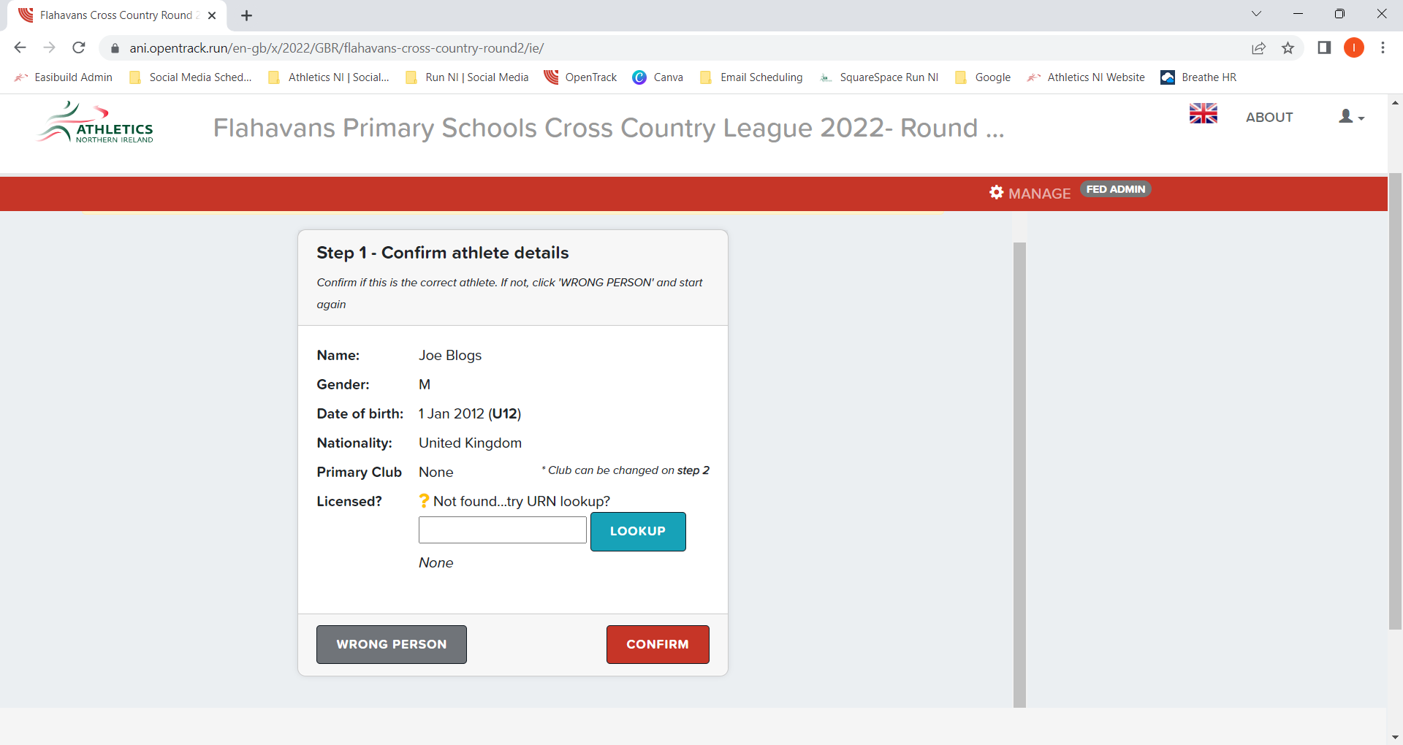

# Step 4

Enter the name of the school the pupil is representing in the second box named ‘Enter Organisation name or code …’ then click ‘Ok’:

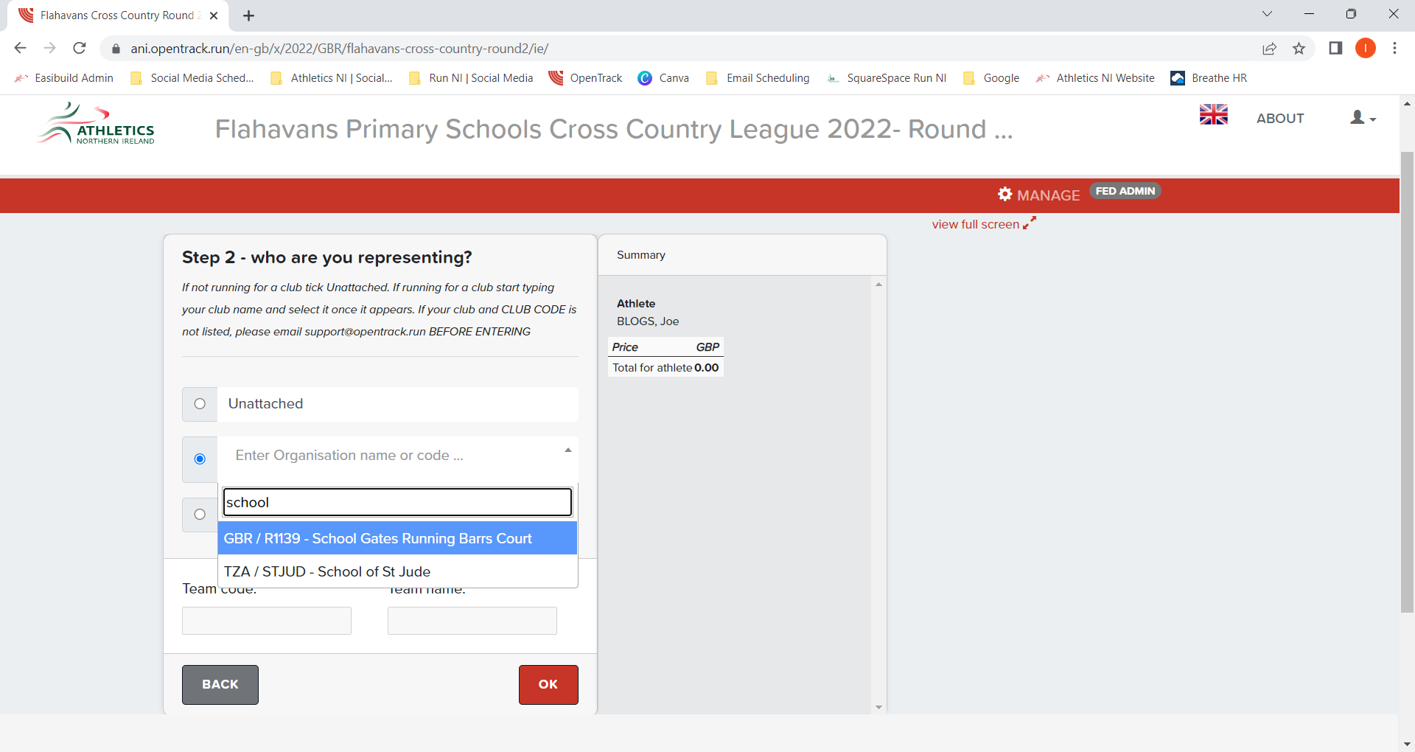

# Step 5

Click on the ‘XC Flahavan’s Boys/Girls Race’ to enter your pupil. However, click on ‘XC Flahavan’s Fun Run’ if your school has exceeded a team of 6 boys and 6 girls for the ‘XC Flahavan’s Boys/Girls Race’ then click ‘Ok’:

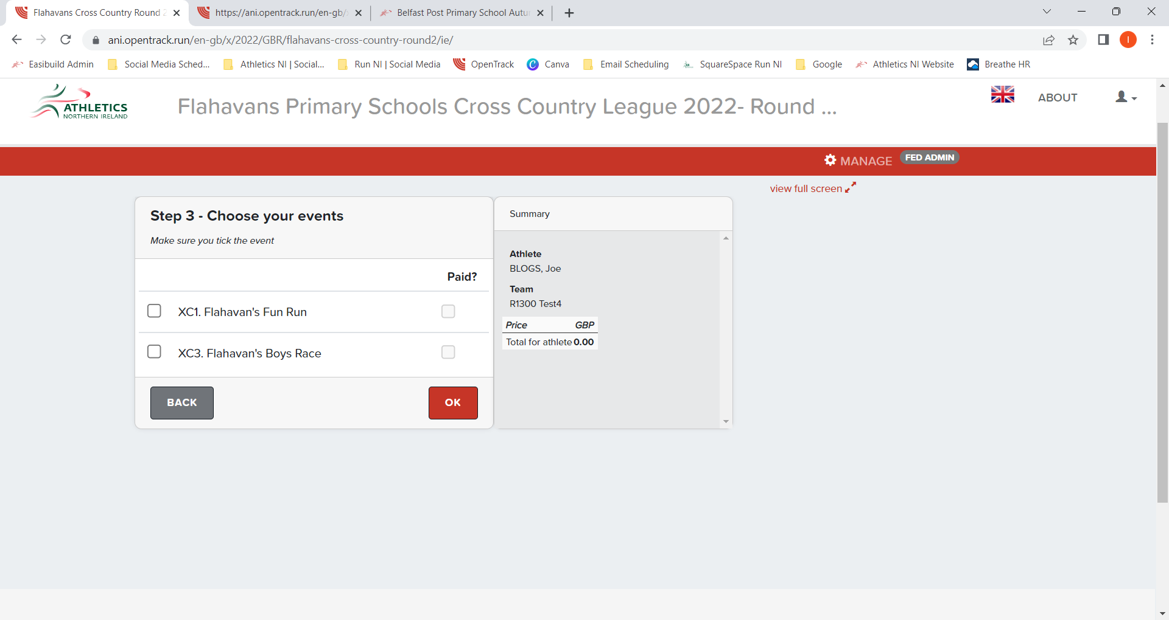

# Step 6

Select which area the pupil’s school is in using the drop down menu ‘1. Please select the area you will be competing in:’ Once this has been selected enter ‘Ok’:

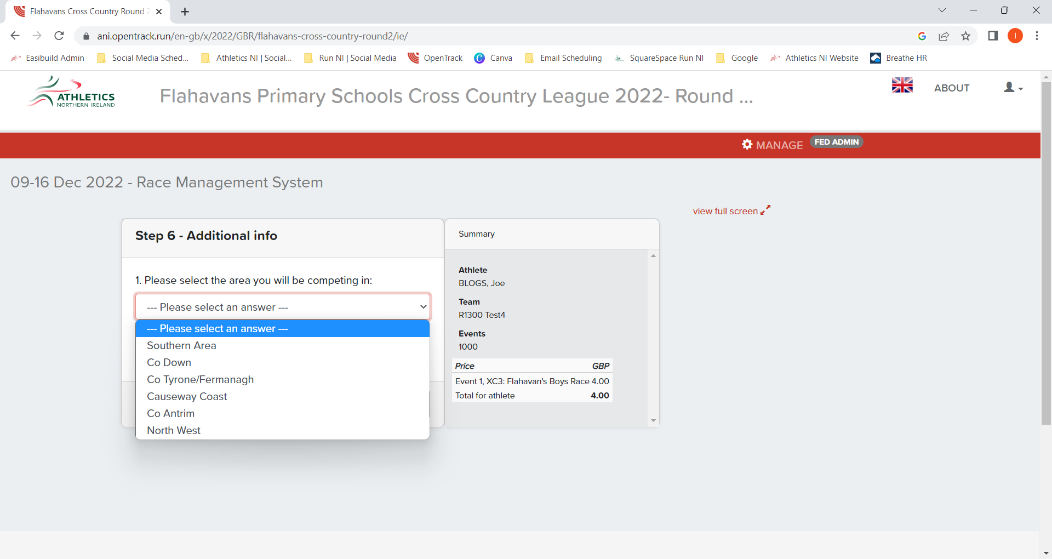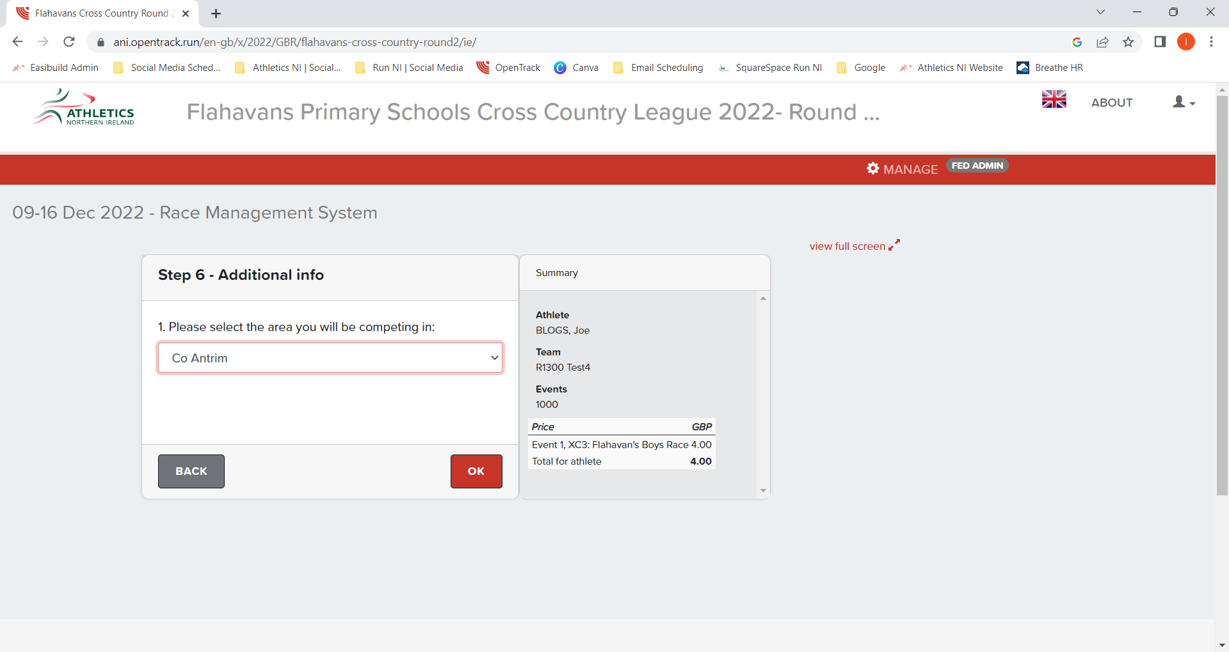

# Step 7

Enter the name of the teacher who will be present on the day of the Flahavan’s Primary School Cross Country event and their phone number. Enter their name in the box under ‘Name: ..of contact’ and their phone number in the box under ‘Phone: ..of contact:

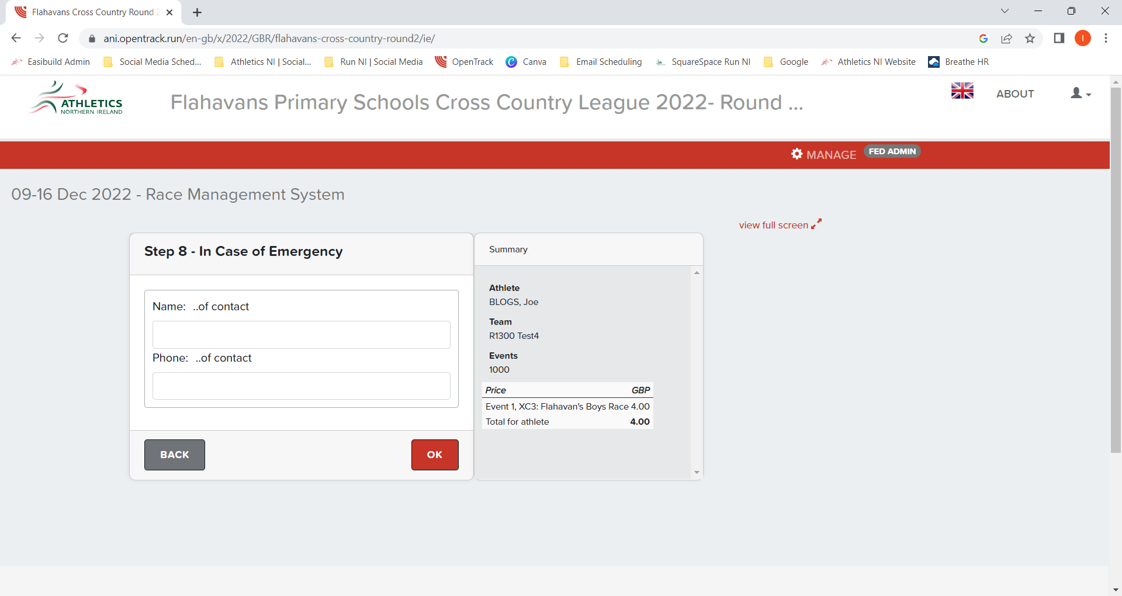

# Step 8

If you wish to enter more pupils click ‘ADD ATHLETE’ and repeat steps 2- 8. However, if you are finished with the pupils you wish to enter click ‘PAY £4.00’:

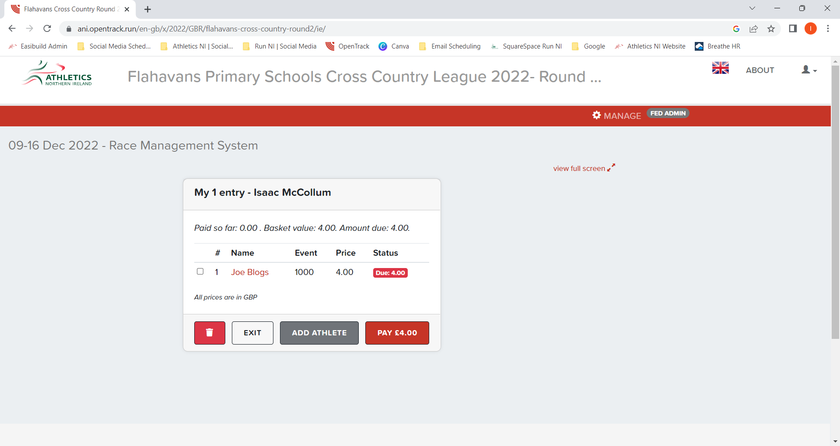

# Step 9

Enter the relevant information for ‘Cardholder name’ and ‘Payment information’. Click on the two boxes beside the red arrows to agree to the terms and conditions. Finally, click ‘PAY £4.00’ and you should receive a conformation email that you have entered the pupils for the event.

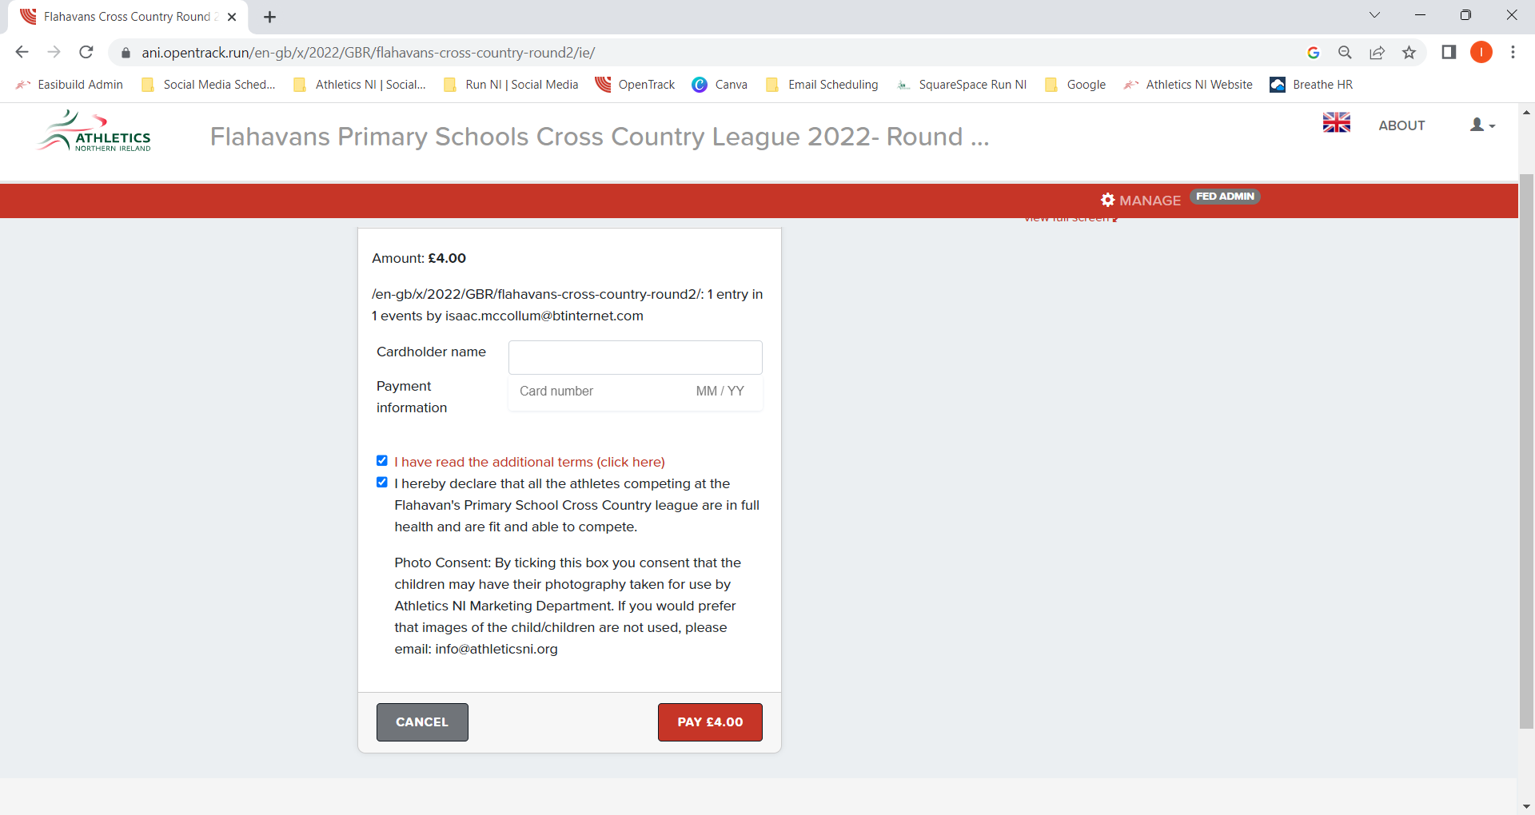

If you have any more queries please contact [info@athleticsni.org](mailto:info@athleticsni.org?subject=OpenTrack%20Entry%20Queries-%20Flahavan's%20Primary%20School%20Cross%20Country).

Team Declarations

If you school has entered a previous round of the Flahavan’s Primary Schools Cross Country League for the 2022-2023 year, then the athletes you had entered will now be on the OpenTrack database. Therefore, you need only follow the above steps for any new athletes.

Follow the steps below to enter those already on the system:

# Step 1

Click on ‘TEAM DECLARATIONS’ where the red arrow is pointing:

# Step 2

Type in the name of the school you are entering in the box called ‘Lookup club …’, click on your school when it comes up and click ‘ENTER’.

# Step 3

Click on the name of the pupil you wish to enter for the Boys Race titled ‘Boys XC3’, click on the small grey arrow pointing left (see red arrow). Repeat for all the athletes you wish to enter, then do the same for the Girls Race ‘Girls XC2’:

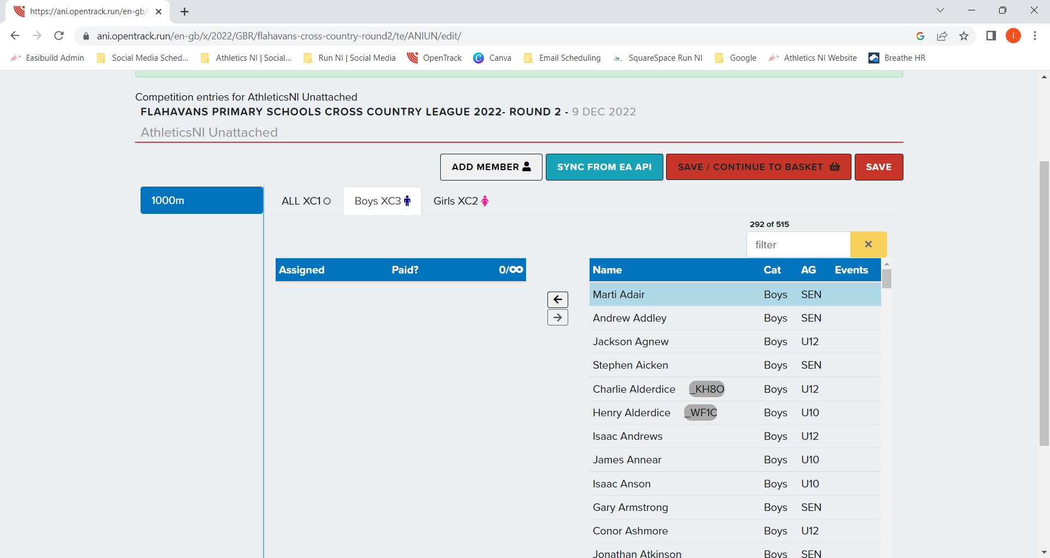

* NOTE- YOU CAN ONLY ENTER A MAXIMUM OF 6 BOYS AND 6 GIRLS FOR THE TEAM RACES *

If you have more than 6 boys and girls you wish to enter, add them to the ‘ALL XC1’ category.

# Step 4

Once all the pupils you wish to enter are on the left table (see red arrow), click ‘SAVE / CONTINUE TO BASKET’:

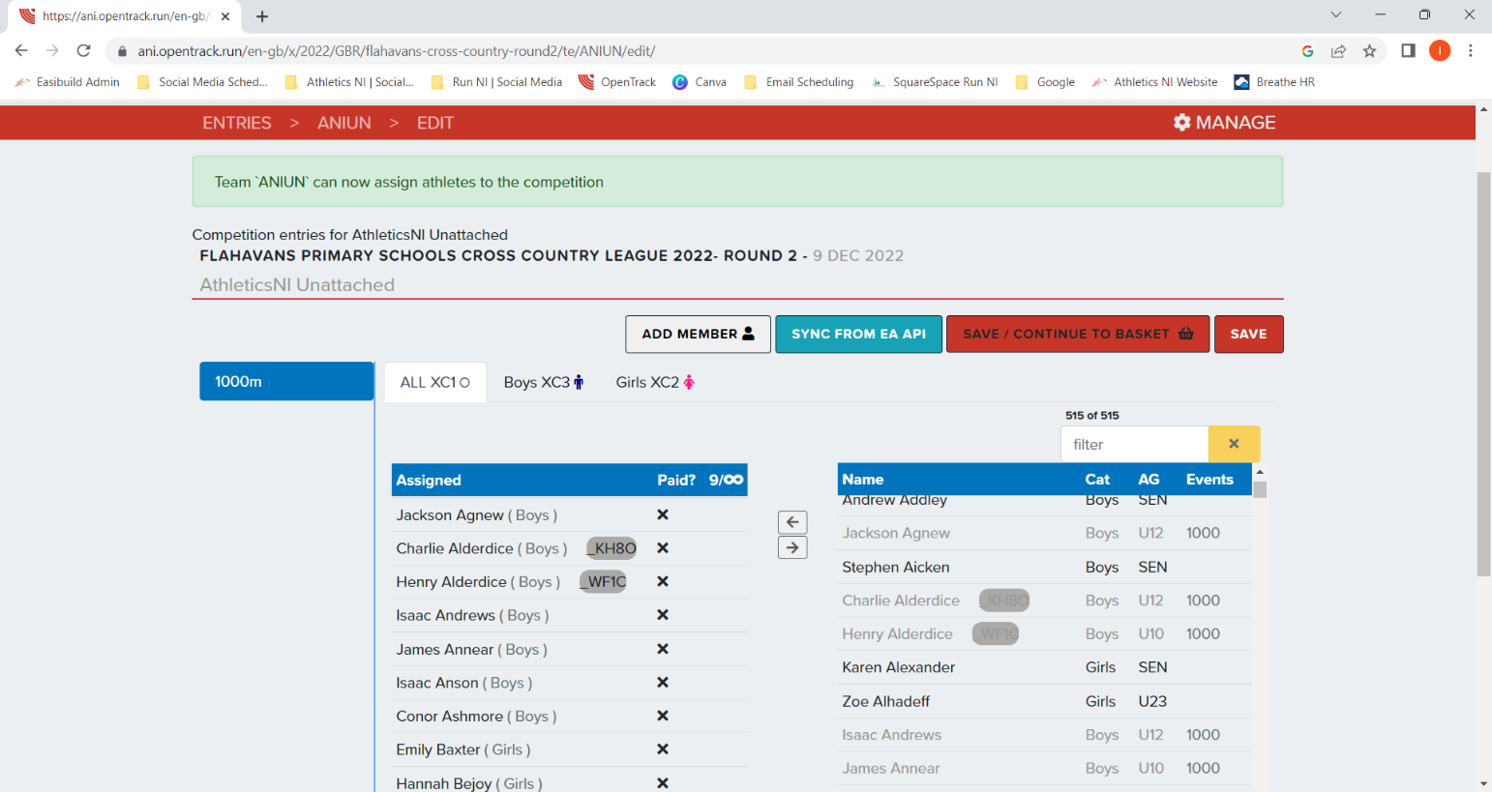

# Step 5

Check to see all the pupils you wish to enter are there then click ‘PAY’:

# Step 6

Enter the relevant information for the boxes beside ‘Cardholder name’ and ‘Payment information’, finally agree to the terms and conditions (see the red arrows).

